PHASE 8 – PROJECT DEMONSTRATION
1. Introduction
The Project Demonstration phase presents the completed LegalEase: AI-Powered Legal Document Generator and demonstrates its major functionalities.
The demonstration shows how a user provides legal document requirements, how the system processes the information through the FastAPI backend and Gemini AI integration, and how the generated document can be reviewed, edited, and downloaded. The demonstration provides practical evidence of the completed project and its end-to-end workflow.
2. Objectives of the Project Demonstration
The main objectives of the demonstration are:
* To present the completed LegalEase application.
* To demonstrate the user interface.
* To demonstrate AI-based legal document generation.
* To demonstrate FastAPI backend integration.
* To demonstrate document preview and editing.
* To demonstrate TXT, DOCX, and PDF export.
* To show the final generated document.
* To demonstrate the complete project workflow.
3. Demonstration Preparation
Before starting the demonstration, the following components are prepared:
* LegalEase project files
* Python development environment
* Required Python packages
* Gemini API configuration
* FastAPI backend
* Streamlit frontend
* Sample legal document information
* Final output files
The application is checked before the demonstration to ensure that the main features are available.
4. Project Introduction
The demonstration begins with a brief introduction to the project.
Project Name: LegalEase: AI-Powered Legal Document Generator
LegalEase is a Generative AI-based application designed to simplify legal document creation. It accepts user-provided information and generates structured legal documents using Gemini AI. The generated documents can be previewed, edited, and downloaded in TXT, DOCX, and PDF formats.
5. Technology Stack Demonstration
The major technologies used in the project are introduced during the demonstration.
Role | Technology
Core application development | Python
Frontend | Streamlit
Backend | FastAPI
AI-based document generation | Google Gemini
DOCX Generation | Python-docx
PDF Generation | FPDF
FastAPI | Uvicorn

6. Demonstration Workflow
The complete demonstration follows the workflow below:
Open LegalEase
↓
Enter Document Type
↓
Enter Parties
↓
Enter Terms & Conditions
↓
Enter Effective Date
↓
Click Generate Document
↓
FastAPI Backend
↓
Gemini AI Processing
↓
Display Generated Document
↓
Review / Edit Document
↓
Download TXT / DOCX / PDF
↓
Verify Final Document
7. Demonstration of User Input
The first practical step is entering the required legal document information.
The user provides:
* Document Type
* Parties Involved
* Terms & Conditions
* Effective Date
The information is entered through the Streamlit interface.
8. Demonstration of AI Document Generation
After entering the required information, the user selects Generate Document.
The request is sent to the FastAPI backend through the `/generate` endpoint. The backend passes the document requirements to the Gemini AI component. Gemini generates the legal document based on the supplied information. The generated content is then returned to the frontend.
9. Demonstration of Document Preview
The generated document is displayed in the application through the document preview interface. The user can review the generated content before exporting the document. The preview allows the user to verify the generated information and document structure.
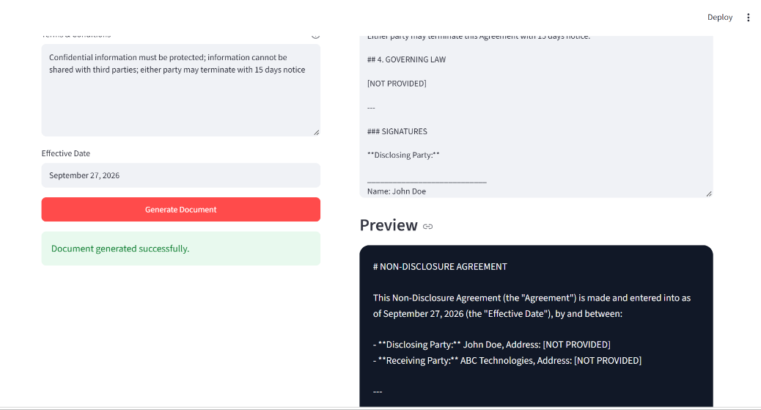

10. Demonstration of Document Editing
The generated document can be edited before final export.
The user can select the editing option and modify the generated content according to the required changes. After making the required changes, the updated content can be used for final document export.
11. Demonstration of Document Export
LegalEase provides multiple download formats.
The available formats are:
* TXT
* DOCX
* PDF
The user selects the required format and downloads the generated document.
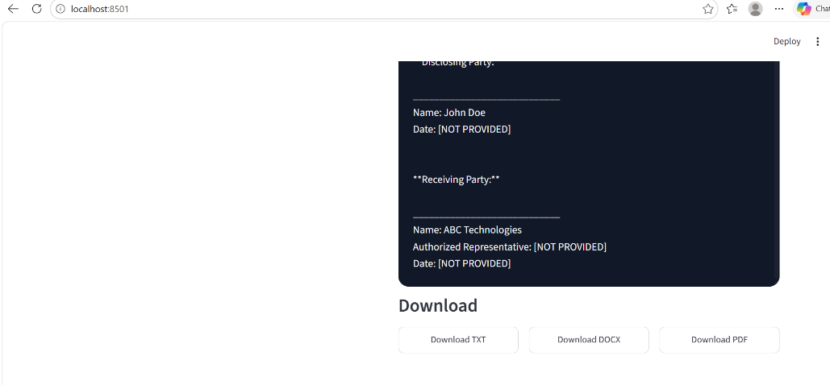
12. Demonstration of Final Output
The downloaded document is opened and verified after export.
The DOCX and PDF outputs can contain the supported document formatting and branding elements.
The final output is checked for:
* Document content
* Title
* Paragraph structure
* Terms and conditions
* Logo
* Footer
* Overall formatting
13. Demonstration of Different Document Types
The project can be demonstrated using different legal document scenarios.
Scenario 1 – Employment Contract
The user enters employment-related details such as roles, responsibilities, compensation, and confidentiality requirements. The system generates an employment contract based on the provided information.
Scenario 2 – Non-Disclosure Agreement
The user enters the parties, scope of confidential information, and effective date. The system generates an NDA based on the supplied requirements.
Scenario 3 – Lease Agreement
The user enters property information, tenant details, and lease terms. The system generates a lease agreement based on the provided information. For the final video demonstration, one complete scenario can be shown from input to final download, while the other scenarios can be briefly demonstrated if time permits.
14. End-to-End Demonstration
The final demonstration shows the complete working process of LegalEase.
The demonstration covers:
1. Opening the application.
2. Entering document information.
3. Generating the legal document.
4. Viewing the AI-generated content.
5. Editing the document.
6. Selecting the required output format.
7. Downloading the document.
8. Opening and verifying the final output.
This demonstrates the integration between the frontend, backend, AI component, and document formatting functionality.
15. Demo Video Requirements
A single complete project demonstration video should be prepared for submission.
The video should clearly show the working of the LegalEase application.
The demonstration should include:
15.1 Project Introduction
Briefly introduce:
* Project name
* Project purpose
* Problem being addressed
* Proposed solution
15.2 Technology Introduction
Briefly explain the technologies used:
* Python
* Streamlit
* FastAPI
* Gemini AI
* Document formatting libraries
15.3 Application Execution
Show the actual application running.
15.4 User Input
Enter the document type, parties, terms, and effective date.
15.5 AI Generation
Click Generate Document and show the generated legal document.
15.6 Preview and Editing
Show the generated document preview and demonstrate the editing functionality.
15.7 Download
Show the TXT, DOCX, and PDF download options.
15.8 Final Output
Open the downloaded document and show the final formatted result.
16. Suggested Demo Video Sequence
The following sequence can be followed while recording the demonstration:
00:00 – 00:30
Project introduction and problem statement.
00:30 – 01:00
Technology stack and project architecture.
01:00 – 02:00
Open LegalEase and enter the document information.
02:00 – 03:00
Generate the legal document using Gemini AI.
03:00 – 03:45
Show the generated document preview and editing functionality.
03:45 – 04:30
Demonstrate TXT, DOCX, and PDF export.
04:30 – 05:00
Open the final document and explain the result.
The duration can be adjusted according to the submission requirements.
17. Demo Video Explanation
During the demonstration, the project can be explained using the following sequence:
Problem → Solution → Technology → Input → AI Processing → Generated Document → Editing → Export → Final Output
This provides a clear explanation of how LegalEase works from the user's input to the final document.
18. Final Demonstration Evidence
The following screenshots are sufficient for the project demonstration section:
1. Final application interface.
2. User input screen.
3. Generated document.
4. Editing interface.
5. Download options.
6. Final DOCX/PDF output.
Screenshots already included extensively in the Development and Testing phases do not need to be repeated unless they are important for demonstrating the final working system.
19. Project Demonstration Outcome
The demonstration verifies the practical implementation of LegalEase.
The completed system demonstrates:
* User-friendly document input.
* FastAPI backend processing.
* Gemini-based legal document generation.
* Dynamic document preview.
* Editable document content.
* TXT export.
* DOCX export.
* PDF export.
* Formatted final document output.
The demonstration provides a complete view of the implemented application and its major functionalities.
20. Final Project Status
The major project activities have been completed through the eight SmartBridge phases:
Phase | Activity | Status
Phase 1 | Brainstorming & Ideation | Completed
Phase 2 | Requirement Analysis | Completed
Phase 3 | Project Design | Completed
Phase 4 | Project Planning | Completed
Phase 5 | Project Development | Completed
Phase 6 | Project Testing | Completed
Phase 7 | Project Document | Completed
Phase 8 | Project Demonstration | Completed

The completed project provides an integrated workflow for AI-assisted legal document generation, editing, and export.
21. Conclusion
The Project Demonstration phase presents the completed **LegalEase: AI-Powered Legal Document Generator** and demonstrates its complete working process. The demonstration covers user input, AI-based document generation, document preview, editing, and export into TXT, DOCX, and PDF formats. The final demonstration video and screenshots provide practical evidence of the implemented system and its major functionalities. The completion of this phase concludes the eight-phase SmartBridge project development process for LegalEase.

